BI
Mini Project
Zomato Restaurant Rating Analysis.

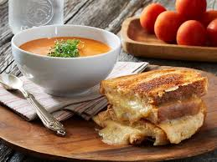


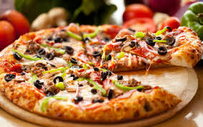

Table of Contents
1 Introduction 2
1.1 Setup Checklist for Mini Project 3
1.2 Instructions 3
2. Problem Statement 4
2.1 Objective 4
2.2 Abstract of the project 4
2.3 Technology used: 4
3. Implementation 5
3.1 Summary of the functionality to be built: 5
3.2 Guidelines on the functionality to be built: 6
3.3 Data Model: 11
4. Informatica Mapping 12
5. Sample Reports 17

Introduction

This document outlines a mini project. The project is to develop Zomato Restaurants Reporting System.
This document contains the work flow of the system and gives guidelines on how to build the functionality gradually.

Setup Checklist for Mini Project
Minimum System Requirements
- Intel Pentium 90 or higher (P166 recommended)
- Microsoft Windows 2010 or above.
- Memory: 4GB of RAM (4GB or more recommended)
- Internet Explorer 10.0 or higher
- Oracle 11G / SQL server 2012 or higher
- Informatica 10.2.0/SSIS/Data Stage/ Abinitio
- Tableau Desktop/SSRS/Power BI/ Qlikview

1.2 Instructions
- The code modules in the mini project should follow all the coding standards.
- Create a directory by your name in drive <drive>. In this directory, create a subdirectory MiniProject. Store your Project here.
- You can refer to your course material.
- You may also look up the help provided in the BI docs and documentation provided with respective tools.

2. Problem Statement

2.1 Objective
Development of a Zomato Restaurant Rating Analysis.

2.2 Abstract of the project
The culinary in India is as varied as its culture. On every 10 kilometers of distance we find the variety in food. With increasing technology we order food online. Amongst all the food applications Zomato is one which is very widely used.
The purpose of this project is to analyze which restaurant is popular in a particular locality of a particular city. It collects the data on various attributes like City, Cuisines, rating in number, rating in text, Average cost of two person, availability of table and online booking. There are 13 prime cities of India, 226 restaurants with 28 different cuisines spread across 137 different localities of these cities.

2.3 Technology used:
- Oracle 11G/ SQL server(Database)
- Informatica power center/ SSIS / Data Stage/ Abinitio(ETL Tool)
- Tableau Desktop/ SSRS / Power BI/Qlikview(Reporting Tool)

3. Implementation

3.1 Summary of the functionality to be built:
The participants need to develop the Zomato Rating Analysis by building the functionality incrementally in each of the course modules of BI LOT using one of the ETL and reporting tool.

3.2 Guidelines on the functionality to be built:

Project flow
Heterogeneous Sources i.e. operational data (Flat files)
EXTRACT
TRANSFORM
LOAD
Data warehouse (Oracle)
Reports Based On Analysis
REPORT

FINAL_FACT
Fact_ID | Number(p,s)
City_ID | Number(p,s)
Locality_ID | Number(p,s)
Rest_ID | Number(p,s)
Cuisine_ID | Number(p,s)
Average_cost_for_two | Number(p,s)
Rating_ID | Number(p,s)
Delivery_ID | Number(p,s)
Table_booking_ID | Number(p,s)
Votes | Number(p,s)
Price_range | Number(p,s)
Schema Design:
The project follows the start schema approach.
- The Dimension tables are :
- City
- Locality
- Restaurant
- Cuisines
- Delivery
- Table booking
- Rating
- Fact Table is :
- Fact_Zomato

LOCALITY_DIM
Locality_ID | Number(p,s)
Locality_name | Number(p,s)
CITY_DIM
City_ID | Number(p,s)
City_name | Number(p,s)

RESTAURANT_NAME_DIM
Rest_ID | Number(p,s)
Rest_name | Number(p,s)

CUISINE_DIM
Cuisines_ID | Number(p,s)
Cuisine_name | Number(p,s)

CUISINE_DIM
Cuisines_ID | Number(p,s)
Cuisine_name | Number(p,s)
TABLE_BOOKING_DIM
Table_booking_ID | Number(p,s)
Table_booking_avail | Varchar

RATING_DIM
Rating_id | Number(p,s)
Rating_in_star | Number(p,s)
Ratin_in_text | Varchar

- City:
This dimension contains information about the City on which the analysis will be carried out.
This CSV file comprises of the following Fields:
- City_ID
- City_Name

There are 13 Cities namely Bangalore, Chandigarh, Chennai, Goa, Guwahati, Hyderabad, Jaipur, Kolkata, Lucknow, Mumbai, Patna, Pune and Surat.
- Locality:
This dimension contains information about the locality on which the analysis will be carried out.
This CSV file comprises of the following Fields:
- Locality_ID
- Locality_Name

There are 137 localities in 13 cities.

- Restaurant
This dimension contains Restaurants with its name and ID and the CSV file comprises of the following Fields:
- Restaurant_ID
- Restaurant_Name
There are 226 restaurants in 13 cities with various sub-branches and cuisines.
- Cuisine
This dimension contains Cuisines available in various restaurants with its name and ID and the CSV file comprises of the following Fields:
- Cuisine_ID
- Cuisine_Name
There are 28 different cuisines in the dataset to carry out the analysis. The Cuisines are:
- American
- Asian
- Bakery
- Bengali
- Biryanis
- Café
- Continental
- Desserts
- European
- Fast Food
- Healthy Food
- Hyderabadi
- Italian
- Japanese
- Mediterranean
- Mexican
- Modern-Indian
- North Indian
- Rajasthani
- Sea Food
- South Indian
- Street Food
- Table_booking:
This dimension contains information about the Table booking availability on which the analysis will be carried out.
This CSV file comprises of the following Fields:
- Table_booking_id
- Table_booking_avail
- Delivery:
This dimension contains information about the Delivery on which the analysis will be carried out.
This CSV file comprises of the following Fields:
- Delivery_ID
- Delivery_avail
- Rating:
This dimension contains information about the Rating on which the analysis will be carried out.
This CSV file comprises of the following Fields:
- Rating_ID
- Rating_in_stars
- Rating_in_text

The Fact Table is:
- Fact_Zomato
This is a Fact table that contains the IDs of all the cities, restaurants, locality and cuisine along with the cost for two people, ratings and availability of tables and online delivery
- Fact_ID
- City_ID
- Locality_ID
- Rest_ID
- Cuisine_ID
- Average_cost_for_two
- Rating_ID
- Delivery_ID
- Table_booking_ID
- Votes
- Price_range

3.3 Data Model:
%3CmxGraphModel%3E%3Croot%3E%3CmxCell%20id%3D%220%22%2F%3E%3CmxCell%20id%3D%221%22%20parent%3D%220%22%2F%3E%3CmxCell%20id%3D%222%22%20value%3D%22CITY_DIM%22%20style%3D%22swimlane%3BfontStyle%3D1%3BchildLayout%3DstackLayout%3Bhorizontal%3D1%3BstartSize%3D26%3BfillColor%3D%23C3ABD0%3BhorizontalStack%3D0%3BresizeParent%3D1%3BresizeParentMax%3D0%3BresizeLast%3D0%3Bcollapsible%3D1%3BmarginBottom%3D0%3BswimlaneFillColor%3D%23ffffff%3Balign%3Dcenter%3BfontSize%3D14%3BlabelBackgroundColor%3Dnone%3B%22%20vertex%3D%221%22%20parent%3D%221%22%3E%3CmxGeometry%20x%3D%22120%22%20y%3D%2246%22%20width%3D%22160%22%20height%3D%2278%22%20as%3D%22geometry%22%2F%3E%3C%2FmxCell%3E%3CmxCell%20id%3D%223%22%20value%3D%22CITY_ID%22%20style%3D%22text%3BstrokeColor%3Dnone%3BfillColor%3Dnone%3BspacingLeft%3D4%3BspacingRight%3D4%3Boverflow%3Dhidden%3Brotatable%3D0%3Bpoints%3D%5B%5B0%2C0.5%5D%2C%5B1%2C0.5%5D%5D%3BportConstraint%3Deastwest%3BfontSize%3D12%3B%22%20vertex%3D%221%22%20parent%3D%222%22%3E%3CmxGeometry%20y%3D%2226%22%20width%3D%22160%22%20height%3D%2226%22%20as%3D%22geometry%22%2F%3E%3C%2FmxCell%3E%3CmxCell%20id%3D%224%22%20value%3D%22CITY_NAME%22%20style%3D%22text%3BstrokeColor%3Dnone%3BfillColor%3Dnone%3BspacingLeft%3D4%3BspacingRight%3D4%3Boverflow%3Dhidden%3Brotatable%3D0%3Bpoints%3D%5B%5B0%2C0.5%5D%2C%5B1%2C0.5%5D%5D%3BportConstraint%3Deastwest%3BfontSize%3D12%3B%22%20vertex%3D%221%22%20parent%3D%222%22%3E%3CmxGeometry%20y%3D%2252%22%20width%3D%22160%22%20height%3D%2226%22%20as%3D%22geometry%22%2F%3E%3C%2FmxCell%3E%3C%2Froot%3E%3C%2FmxGraphModel%3E
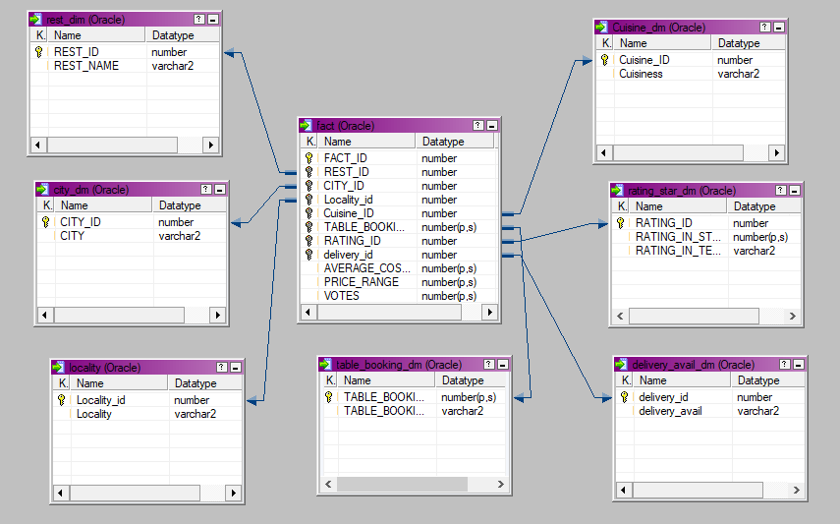
Note: The datatype/length for the Dimension/fact table attributes can be changed as required.Additional fields can be added,if required.

4. Informatica Mapping

Dimension Tables:
Transformations used:
          - Sorter Transformation
          - Filter Transformation
          - Sequence Generator
          - Store Procedure

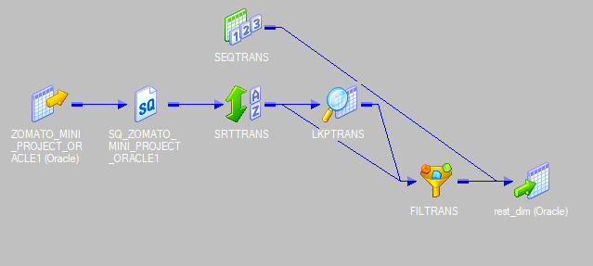
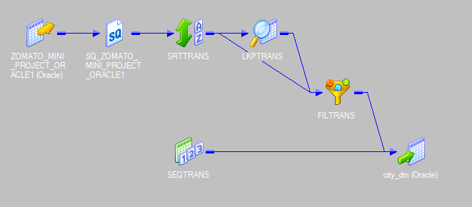
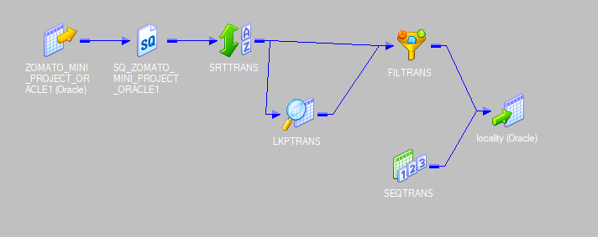
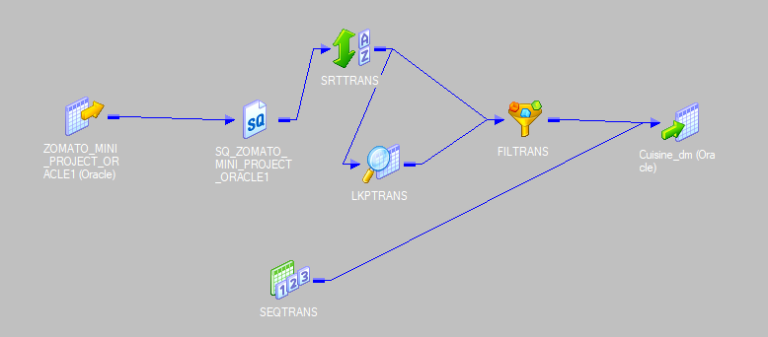
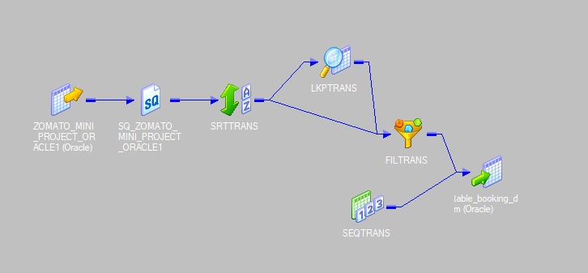
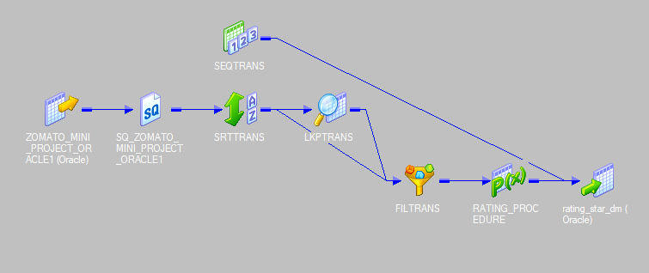
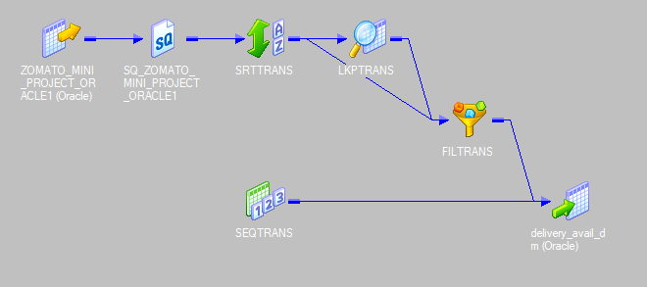

Fact Table:

Transformations Used:
          - Lookup Table
          - Source Qualifier

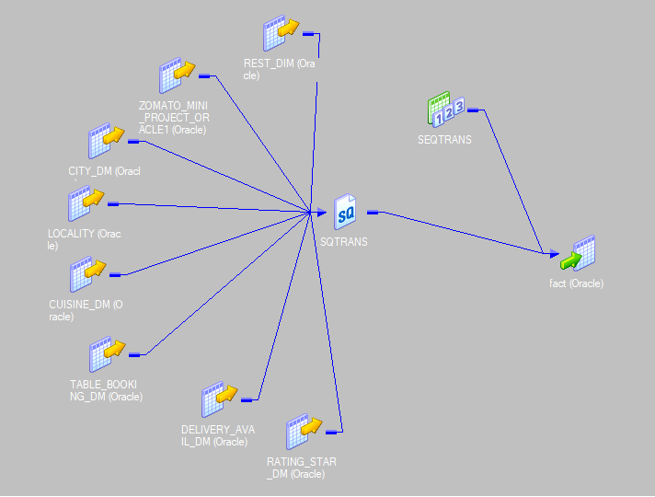

5. Sample Reports

